A284-Asia-Harappa-Bull-Pipal Tree-Water-Terracotta-2600–1900 BCE

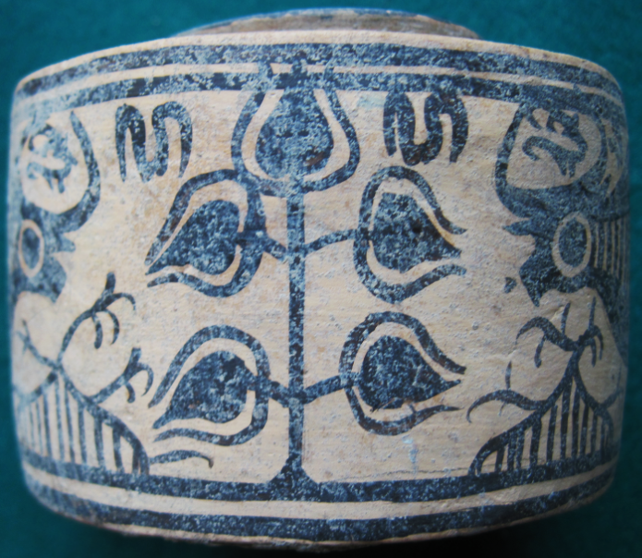 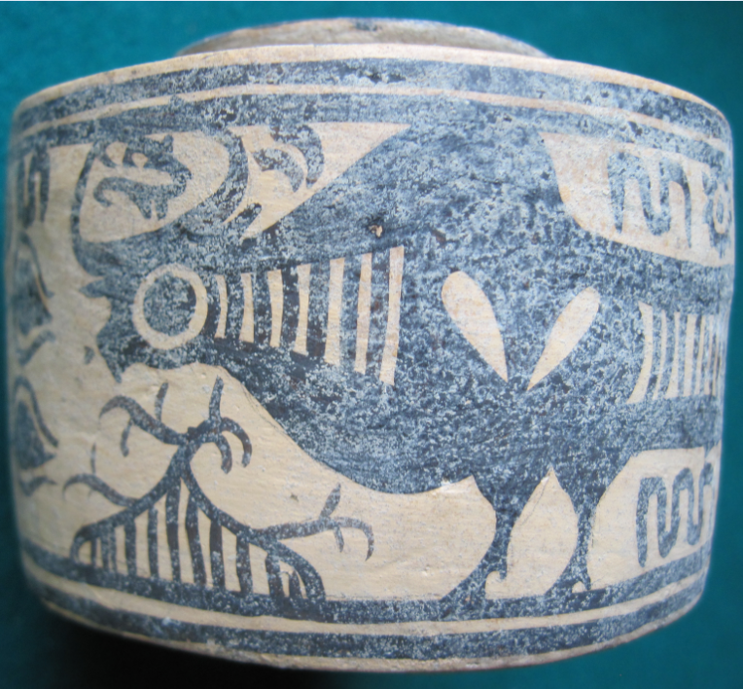

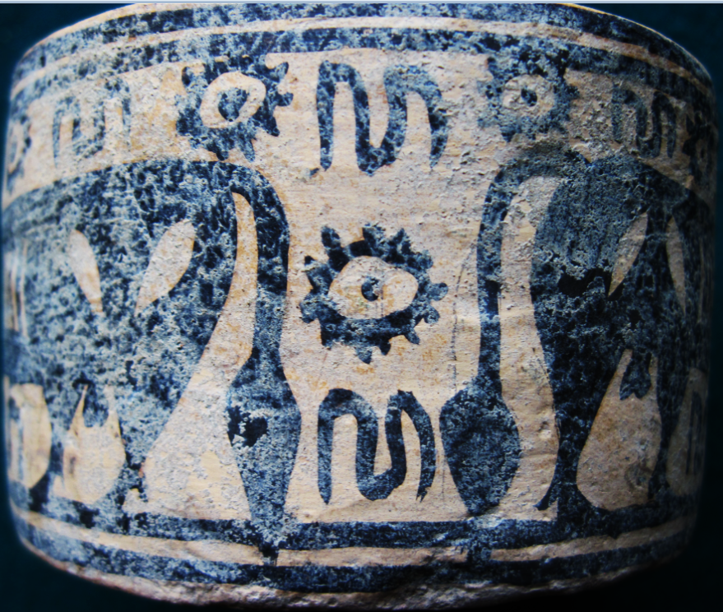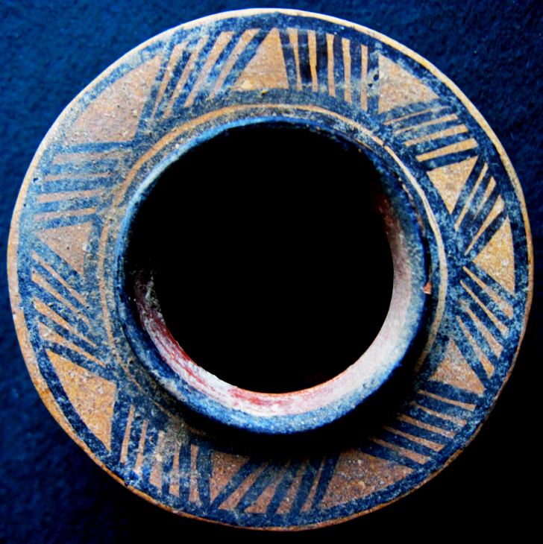 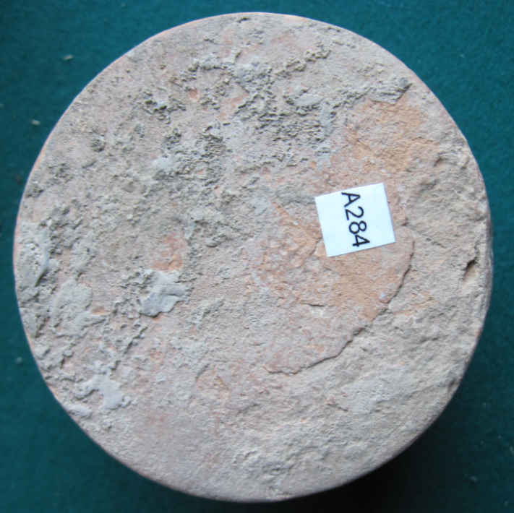

Figs. 1-5. Harappa-Bull-Pipal Tree-Water-Terracotta-2600–1900 BCE.

**Case no.: 3**

**Accession Number: A284**

**Formal Label:** Harappa-Bull-Pipal Tree-Water-Terracotta-2600–1900 BCE

**Display Description:**

This third millennium BCE Harappa terracotta combines symbolism of the tiger, the pipal tree (*Jicus religiosa*), gazelles, water and migrating birds. Zebu cattle were important in Harappa’s agrarian economy, and the zebu bull assumed a rôle as the symbol of fertility and fruitfulness.

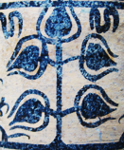

Fig. 6. Pipal Tree symbolism. Detail.

The Pipal Tree suggests fruitfulness in two ways. First, economic prosperity is implied by the water symbol above its leaves, and, secondly, personal, intellectual enlightenment, in which the vertical structure of the tree metaphorically suggests successive enlightenment chackras.

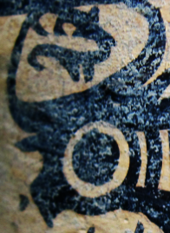

Fig. 7. Zebu bull with circular round eyes and a gazelle between its horns.

This suggestion appears supported by the image of a zebu bull with circular round eyes a symbol of spiritual insight. A gazelle has been painted between the zebu’s horns. This central placement suggests an important meaning and it may signify Vayu, a primary Hindu deity, lord of the winds. “The other atmospheric gods are his associates: Vayu-Vatah, Parjanya, the Rudras and the Maruts. All of them are fighters and destroyers, they are powerful and heroic” (Bhattacharji 1984). He is also father of Bhima and the spiritual father of Hanuman. He is also known as Anil (Air, Wind), Vyān (Air), Vāta (Airy Element), Tanum (Wind), Pavan (Purifier), and Prāṇa (Breath). All these associations suggest a spiritual element to be achieved (Raju 1954).



Figs. 7, 8. Zebu bulls’ carcass symbols.

Symbols on the Zebu Bulls’ carcasses may signify painting or branding suggest by Harappa pastoralists to identify their domesticated cattle by individual ownership marks.

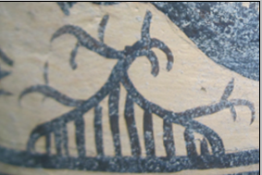 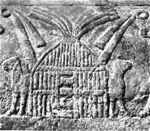

Figs. 9, 10. Triangular images with parallel lines are figures of reed bowers for cattle. Image on the right from a terra cotta panel ca 2500 BCE, lower Mesopotamia. From <http://www.laputanlogic.com/articles/2004/01/24-0001.html>

These triangular images are of a reed bower (barn-like structure) in which the Zebu bull is taken at night.

Similar structures are well-known to the “Marsh Arabs” in the lower Tigris-Euphrates river valley. Metaphorically they may signify the security of having such a protected shelter.



Fig. 11. An image couplet suggestive of water and sun. This couplet is repeated five times.

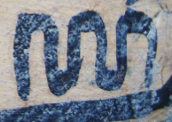

Fig. 12. A variant of the water symbol, this may indicate an intensified meaning of water, perhaps a stream or river.

Water and Sun are important symbols for any settled farming community and their added significance for the people at Mehrgarh is that they, like the Zebu bull become symbols for the sustainability of life.

These are some of the oldest Harappan symbols, and they represent a larger, more coherent text than do any of the steatite stamps. Ceramics, then, may provide a point of access to the glyphs and syntax of the Harappan and Mohenjo-Daro stamp seals.

**LC Classification:** DS486 H35  
**Date or Time Horizon:** 2600–1900 BCE

**Geographical Area:** Harappa

**Map, GPS coordinates:**

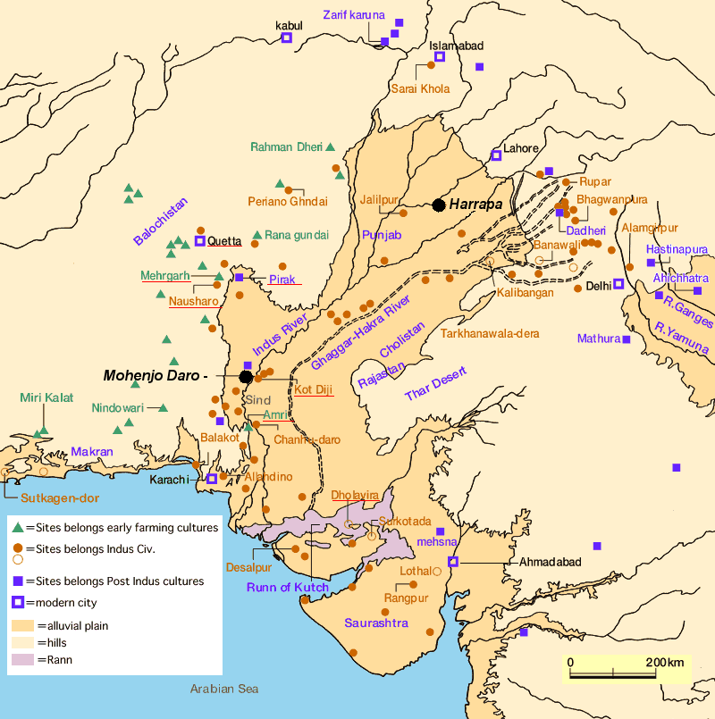

Fig. 13. Map of Indus sites from https://encrypted-tbn0.gstatic.com/images?q=tbn:ANd9GcSnoolUCyM4saSet1fqKCqzYEWJhfDBzJsATILKpXYgG8P2maLY.

**Map, GPS coordinates:** [27°19′45″N 68°08′20″E](https://tools.wmflabs.org/geohack/geohack.php?pagename=Mohenjo-daro&params=27_19_45_N_68_08_20_E_type:landmark)

**Cultural Affiliation:** Harappa

**Media:** Terracotta, black pigment

**Dimensions:** Dia 90.23 mm, 3.55 in; H 64.99 mm, 2.56 in

**Weight:**

**Condition: original**

**Provenance:** unknown

**Discussion:**

Following the Harappan civilization’s decline, northwestern India was settled by Aryan-speaking peoples who were pastoral and the economic importance of cattle is reflected in the ritual and symbolism of the Vedic literature of Hinduism. At this time-horizon 1900-1600 BCE, during the Hindu social transformation, the pipal tree became the symbolic abode of the Hindu trinity of masculine deities: Shiva, Vishnu and Brahma.

**References:**

[Bhattacharji](https://www.google.com/search?tbo=p&tbm=bks&q=inauthor:%22Sukumari+Bhattacharji%22), Sukumari. 1984 *Literature in the Vedic Age:* *The Saṃhitās*. New Delhi: K.P. Bagchi.

Jansen, Eva Rudy; Tony Langham. 1993. *The book of Hindu imagery: The Gods and their Symbols*. New Delhi: Binkey Kok Publications.

Raju, P.T. 1954. “The concept of the spiritual in Indian thought,” *Philosophy East and West*, 4 (3): 195–213.

Ratnagar, Shereen. 1981. *Encounters, the westerly trade of the Harappa civilization*. Delhi ; New York : Oxford University Press.

Vats, Madho Sarup. 1999. *Excavations at Harappa: being an account of archaeological excavations at Harappa carried out between the years 1920-21 and 1933-34.* New Delhi: Director General, Archaeological Survey of India, 1999.